- No. the circuit was incomplete
- I felt a slight tingle on the tip on my tongue and it tasted something metallic. Touching copper and zinc strips completes the circuits.

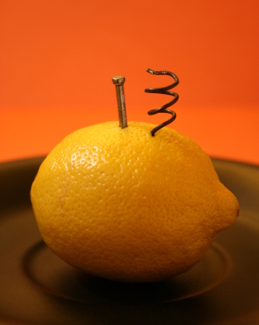
- The current flow from high potential difference to low potential difference. If there is no connection between the high and low potential differences, no current that flows and hence nothing that was felt.
- Screenshot

- The flow of charges from the cell makes the current flow causing the light to light.

- Insulators and conductors
Objects that allowed electricity flow | Objects that did not allow the electricity flow
Copper wire, aluminum plate, gold strip, silver strip | Plastic, paper, glass, rubber, wood

- Screenshot
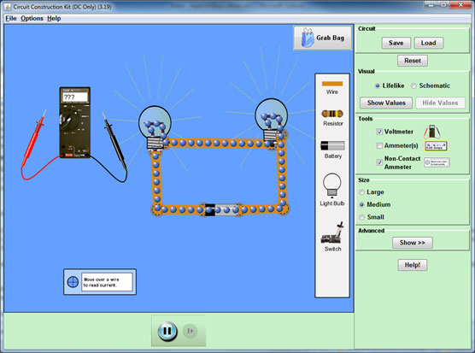
- The two bulbs went off when the screen was disconnected since they are in series and the current did not flow after disconnection.
- Bulbs in parallel
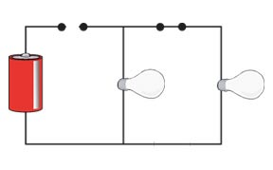
- This is a simple parallel circuit which consist two bulbs and each have different circuit path wired to the dry cell. When break the connection at one bulb the circuit remain complete though only one bulb light.

- Three bulbs A, B and C connected in series and parallel
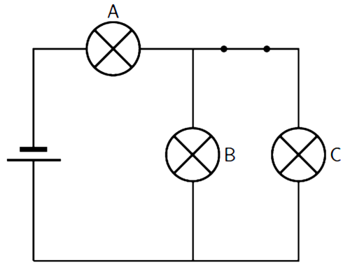
- Series connection. Parallels circuits have few parts as compared to series circuits. The currents supplied will take long time and hence cheap.
- Parallel, house equipment such as fun, refrigerator, bulbs and should be in parallel since the disconnection does not affect the other devices.
- Diagram of two resistors in series with ammeter and voltmeter
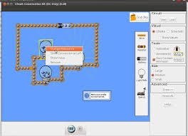
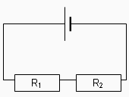

- Value of currents and volts
Volts (v) | Current A
10 | 0.16
220 | o.16
The current is constant thought the circuit
- A circuit with two resistor in parallel and measure the current and voltage. Take a screen short of the circuit
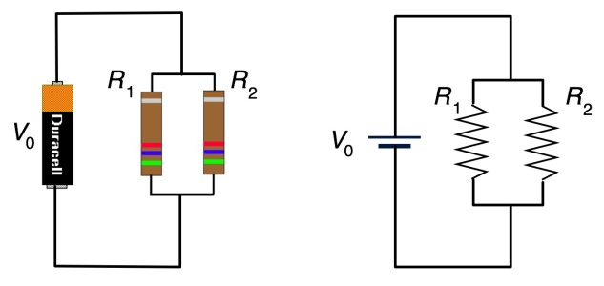
- R₁ =1Ω and R₂=4Ω
In series R_{total} = R₁ + R₂
=1Ω + 4Ω =5Ω
The two resistances have a common current flowing through them as it can only take one part. Resistors in series are complex and can be replaced by one single equivalent resistor R_{EQ} or impendence Z_{EQ}. All resistors obey ohm’s law and Kirchhoff’s laws. Each resistor in a circuit has different potential differences. The total voltage is given by the sum of individual voltage.
V_{AB} = V_{R1} + V_{R2} + V_{R3}
In parallel, R_{total} = R₁ XR₂/ R₁ + R₂
1 X 4/5=0.8Ω
The total resistance is nit equivalent to the sum of the resistors used and it is always less than any of the branch resistor. Addition of parallel branches to the circuit, the total current will decrease as stated by ohm’s law. The sum of the currents through each path is equal to the total currents and the voltage is same across each component of the parallel circuits.
- Combination of both parallel and series arrangement of resistors.
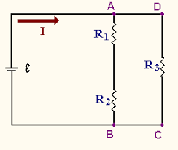
- The values for the currents and resistor for each resistor. Then confirm that they comply with the statement above.
Resistor R1 and R2 are in series while the combination of resistor AR1and R2 are in parallel with R3
R1 = 1Ω, R2 = 4Ω, R3= 5Ω
Total for R1 and R2 = 1+3=5Ω
The effective resistance for the whole circuit
Total resistance = 4 x5/5+4 =2.22Ω
Current = V/ R
1.5/2.22 = 0.675A

